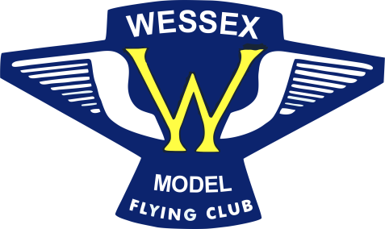 | Wessex Model Flying Club
MEMBERSHIP APPLICATION FORM 2024
References:
BMFA Membership portal: https://bmfa.justgo.com/Account.mvc/SignIn
Flying drones and model aircraft: https://register-drones.caa.co.uk/
Wessex MFC Rules: http://wessexmodelflyingclub.org.uk/club-rules/

Full Name:
Address:

Post Code:
Tel No (Incl. code): |  | Mobile:
Email:
DOB:

BMFA membership and CAA registration are compulsory.

Note 1: The Senior club fee is reduced to £80 if it is paid by 1st January 2024
Note 2: A Junior is anyone under the age of 16 years on the 31st December 2023

 | Senior | Junior | Non-Flying
Club Fees | £85 | £16 | £20
Total £
Member's personal BMFA/CAA Details:

CAA Flyer ID: CAA Operator ID: CAA Renewal Date:
BMFA Number: BMFA Renewal Date:
BMFA or LMA Achievement awards held:
e.g. A (FW), B, Examiner, None:#

Please make your payment by bank transfer: HSBC sort code: 40-44-33 A/C No. 71384961 (please put your name in the reference section) you will still need to post a completed membership form to the Membership Secretary.

GDPR Compliance: For us to be able to administer your membership and to inform you of meetings, events, rule changes, etc. we keep your Name, Address, Phone Number, BMFA number, and DOB in our database for the club's exclusive use. You may review what data we hold and request its deletion at any time.

Please sign below to acknowledge that you have accessed the club rules and that you have read and understood them. (Printed rules available on request.)

SIGNED………………………………………DATE………………………….

Send your application to the Club Membership Secretary - Bob Condrey, 2 Leighton Park West, Westbury, Wiltshire. BA13 3RW or email to secretary@wessexmodelflyingclub.org.uk

I consent to the use of my images for promotional purposes
We like to promote our hobby occasionally by posting notices on our social media channels of awards and events that may contain images of you and/or your models. By ticking the box below, you are giving your consent to allow this.

There are four WhatsApp groups available. Please indicate which group(s) you would like to join by ticking the appropriate boxes.

Planning |  | Gear For Sale |  | Indoor Flying |  | Chat

Note: You cannot fly on club sites after 31st December 2023 until you have paid your membership fees as you will not be insured. Membership runs from 1st January to 31st December.

